Assignment 2-Case Study

Stage 4 Lab Activities

Implementing the SmartCare Domain Layer
DESIGN FIRST -> AI PAIR PROGRAMMING -> REVIEW -> VERIFY | 1hour

A - Revisit Approved UML
Confirm responsibilities, attributes and relationships before coding.

Using the approved domain classes in discussion pdf to present the final UML. Also following camelCasing as rule of thumb naming convention for UML, this can be further dialed down to naming convention for each lang (since we use python in code we will use snake_case)
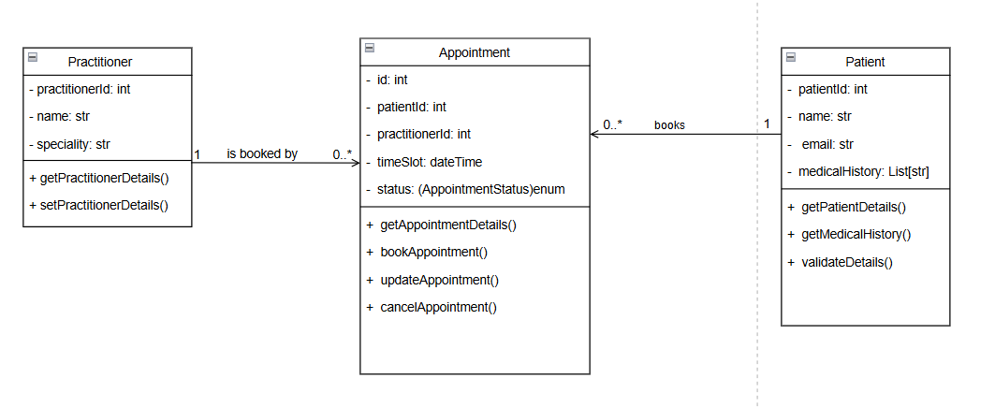

B - Implement Patient: AI OFF
Implement Patient with type hints and basic validation.
Used the previous skeleton, with minor changes, and implemented the concrete class with type declarations (hints) and validation of invariants (through a sep class function). (Code in main.py)

C - Implement Practitioner: AI OFF
Implement Practitioner with identifier, name and specialty; no database logic.
Code in main.py.

D - Implement Appointment: AI ON
Give AI the approved Appointment UML, business rules and explicit constraints. Ask it to implement only Appointment and agreed enum/exception.
============================
AI Response:
I have added this code as is to a separate file, for documenting purposes. I’ll review, edit, verify and put the final version in main.py
============================

E - Review Generated Code
Check model consistency, unsupported features, public state mutation, unnecessary inheritance, invented dependencies and error handling.
=====================================
Model generated by AI is concrete and consistent (with a bit of added functions), there is no invented dependencies or inheritance (since I constrained it with proper business rules). There is no public state mutation either, state always go from a legal state to another legal state.
These are the functions that I dont think are needed, since we already have a get_status call:
def is_scheduled(self) -> bool:
"""Returns True if appointment is SCHEDULED."""
return self._status == AppointmentStatus.SCHEDULED

def is_completed(self) -> bool:
"""Returns True if appointment is COMPLETED."""
return self._status == AppointmentStatus.COMPLETED

def is_cancelled(self) -> bool:
"""Returns True if appointment is CANCELLED."""
return self._status == AppointmentStatus.CANCELLED
I have removed these functions in the main implementation after reviewing the code through and through.

F - Manual Behaviour Checks
Create valid objects, test invalid input, cancel a scheduled appointment and attempt an illegal repeated transition.
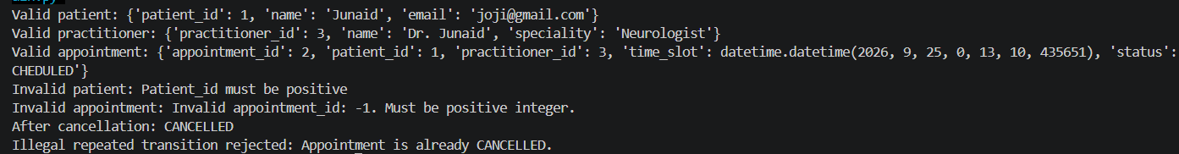
Works completely, and correctly, as intended.

G - Refactor
Remove unnecessary code and make implementation simpler and design-consistent.
Final code in main.py is refactored.

H - AI Engineering Log
Record prompt, generated contribution, decisions and verification evidence.
(Used Claude, because I am unable to access copilot due to some issues)
Prompt:
Act as a Python pair programmer. Implement only the Appointment class from the approved SmartCare UML. Use type hints and an AppointmentStatus enum. Cancelled appointments remain as objects. Do not add database, UI, notification or service classes. Protect status transitions and explain any decision not directly visible in the UML.
Approved Domain Class:
Appointment → appointment_id, Patient, Practitioner, date_time, status + legal state-changing behaviour. Use this enum: class AppointmentStatus(Enum): SCHEDULED = "SCHEDULED" COMPLETED = "COMPLETED" CANCELLED = "CANCELLED"
(i also provided my UML Diagram too, and the original BR + constraints).

Generated Contribution + Decision + Verification :
This is put in a separate file in source code. Also, AI generated mostly correct code, except for 3 functions I defined above, mostly code was correct, and I removed those 3 function from final implementation. So the final decisions I took was Modified + Accepted, this was because I gave AI concrete business rules, UML diagram, and strict constraints. So it was according to what was defined in approved domain class, and approved FRs. It did add a couple of function on its own that I accepted as is too, because these were utility functions (like validation, getting status, marking status as completed etc.)

Suggested AI prompt
Act as a Python pair programmer. Implement only the Appointment class from the approved SmartCare UML. Use type hints and an AppointmentStatus enum. Cancelled appointments remain as objects. Do not add database, UI, notification or service classes. Protect status transitions and explain any decision not directly visible in the UML.

Reflection
Which AI-generated part did you modify or reject? Why? How did the approved design constrain the AI?
This is put in a separate file in source code. Also, AI generated mostly correct code, except for 3 functions I defined above, mostly code was correct, and I removed those 3 function from final implementation. So the final decisions I took was Modified + Accepted, this was because I gave AI concrete business rules, UML diagram, and strict constraints. So it was according to what was defined in approved domain class, and approved FRs. It did add a couple of function on its own that I accepted as is too, because these were utility functions (like validation, getting status, marking status as completed etc.) The UML, Domain Class, approved FR, enum definition, and suggested prompt constrained AI strictly and stopped it from adding unnecessary stuff and didnt deviate.

